* Install Power BI Desktop and share the final screenshot of the report view page which appears when power desktop starts.

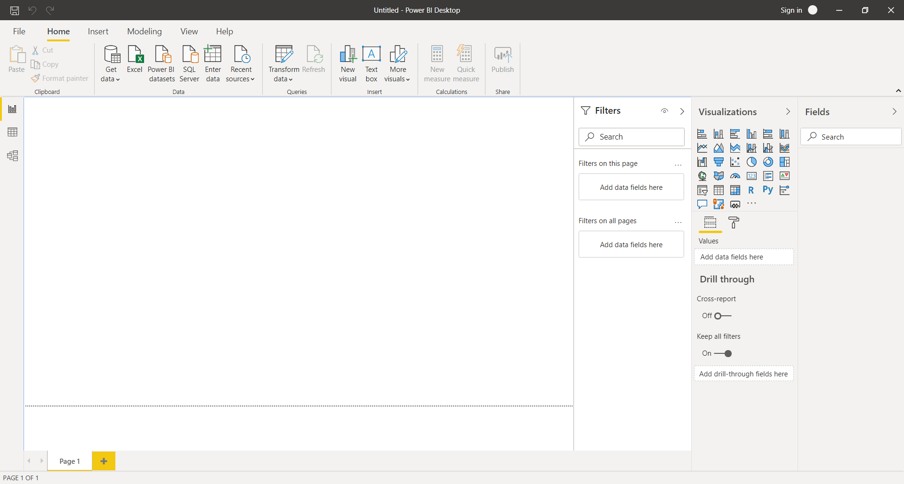

* Prepare a document and with the following screenshot

− Report View

− Data View

− Model View

− Power Query Editor

− Advance Editor

Report View

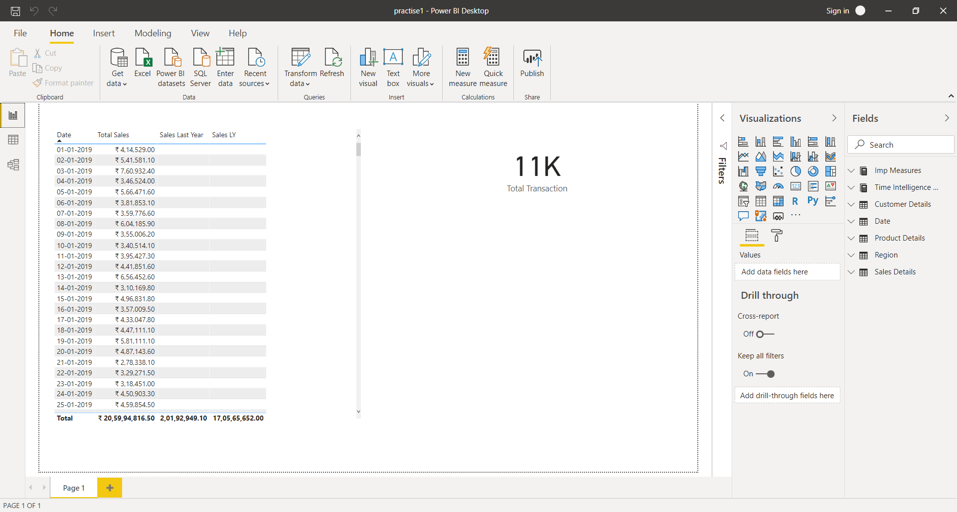

Data View

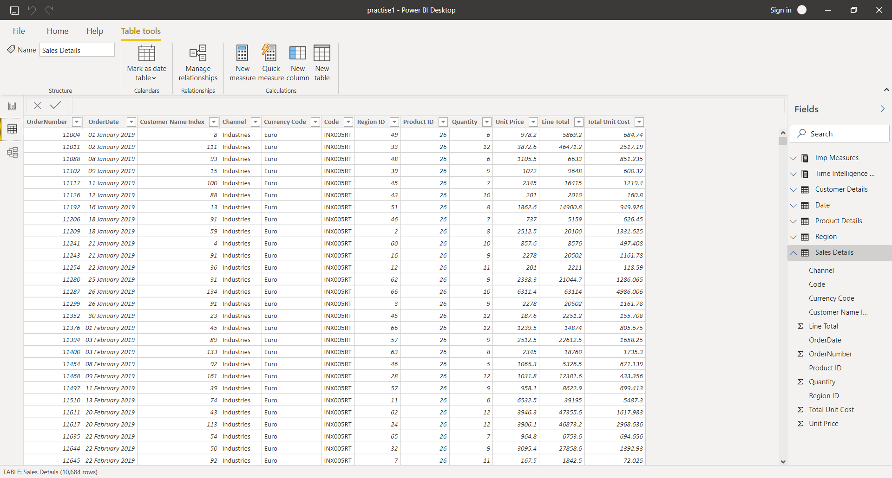

Model View

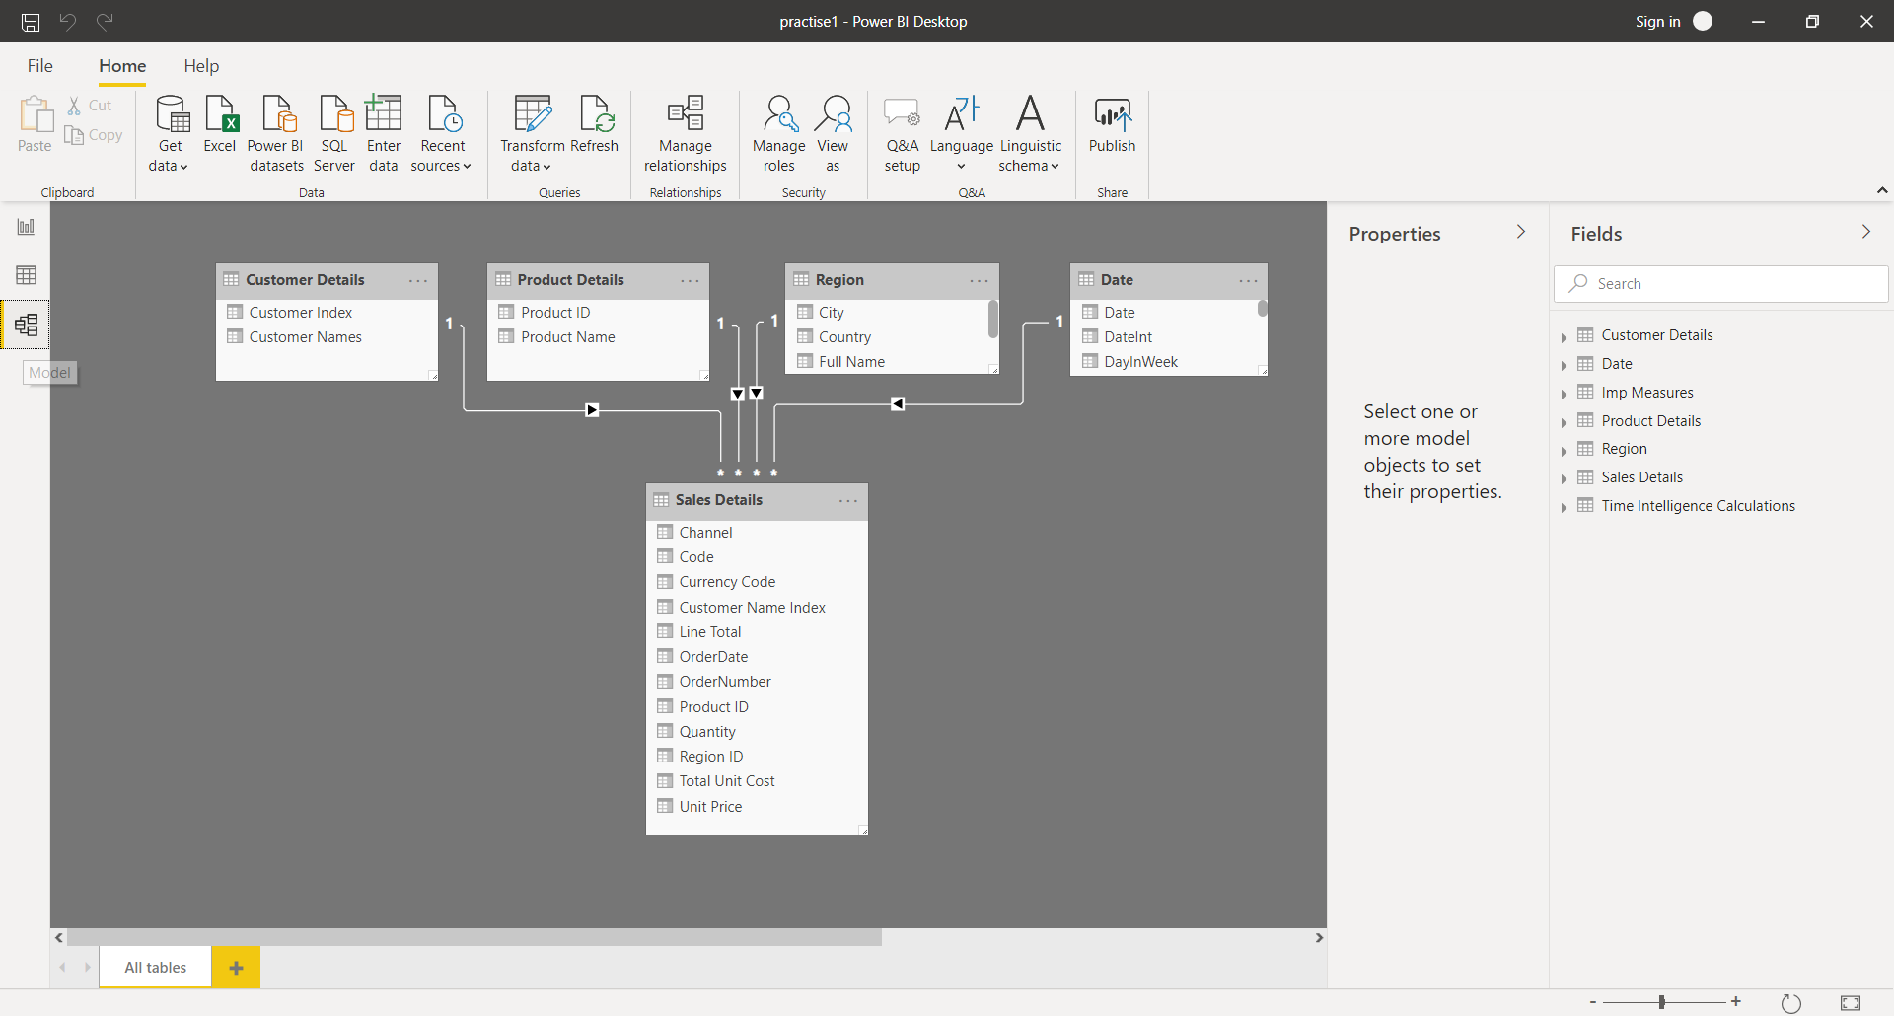

Power Query Editor

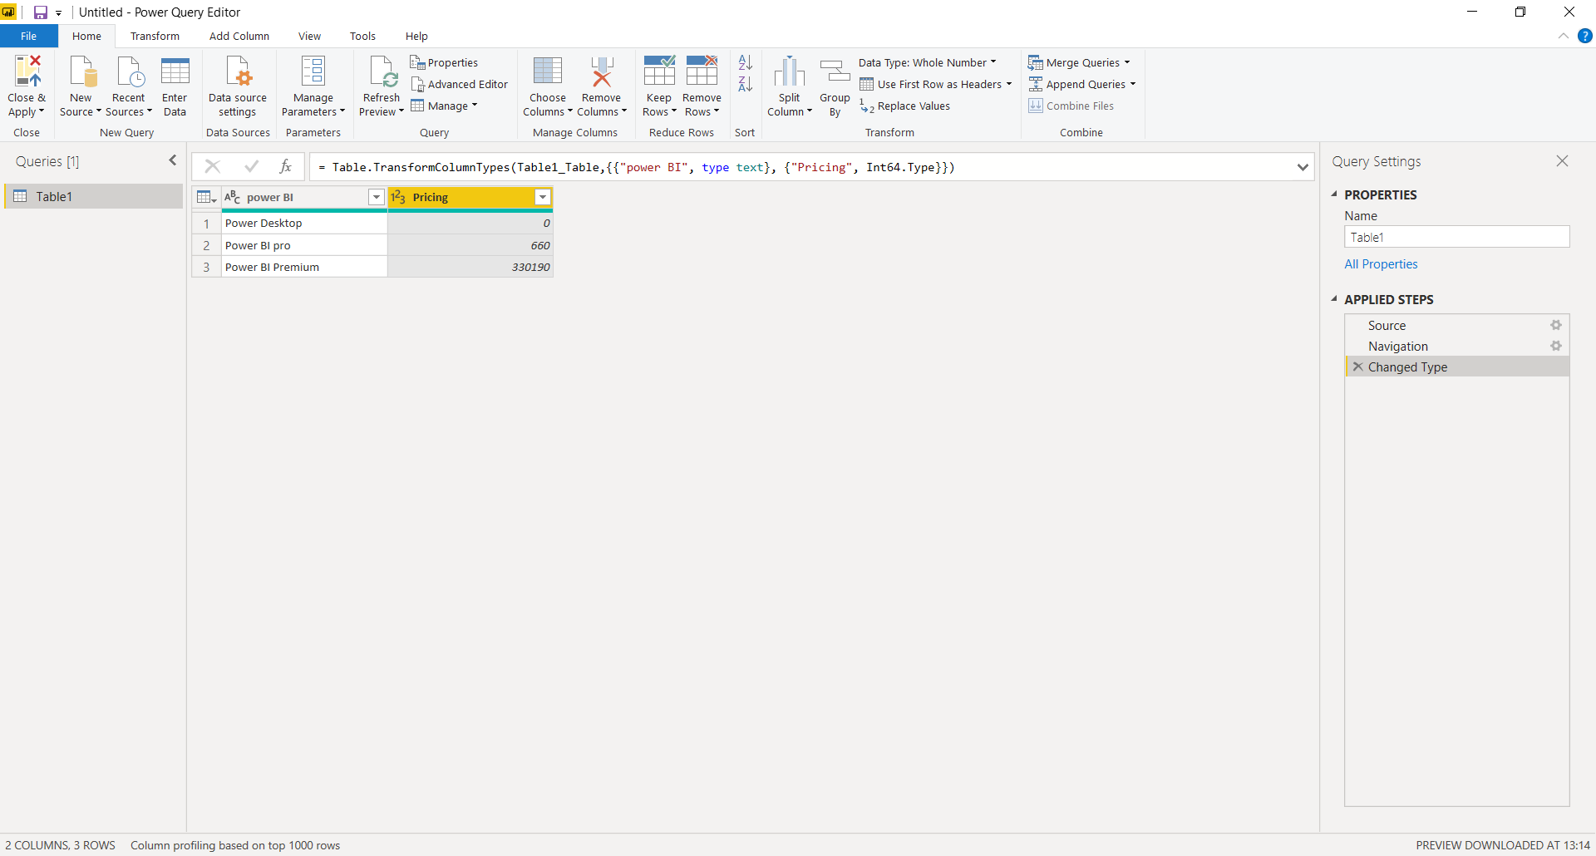

Advance Editor

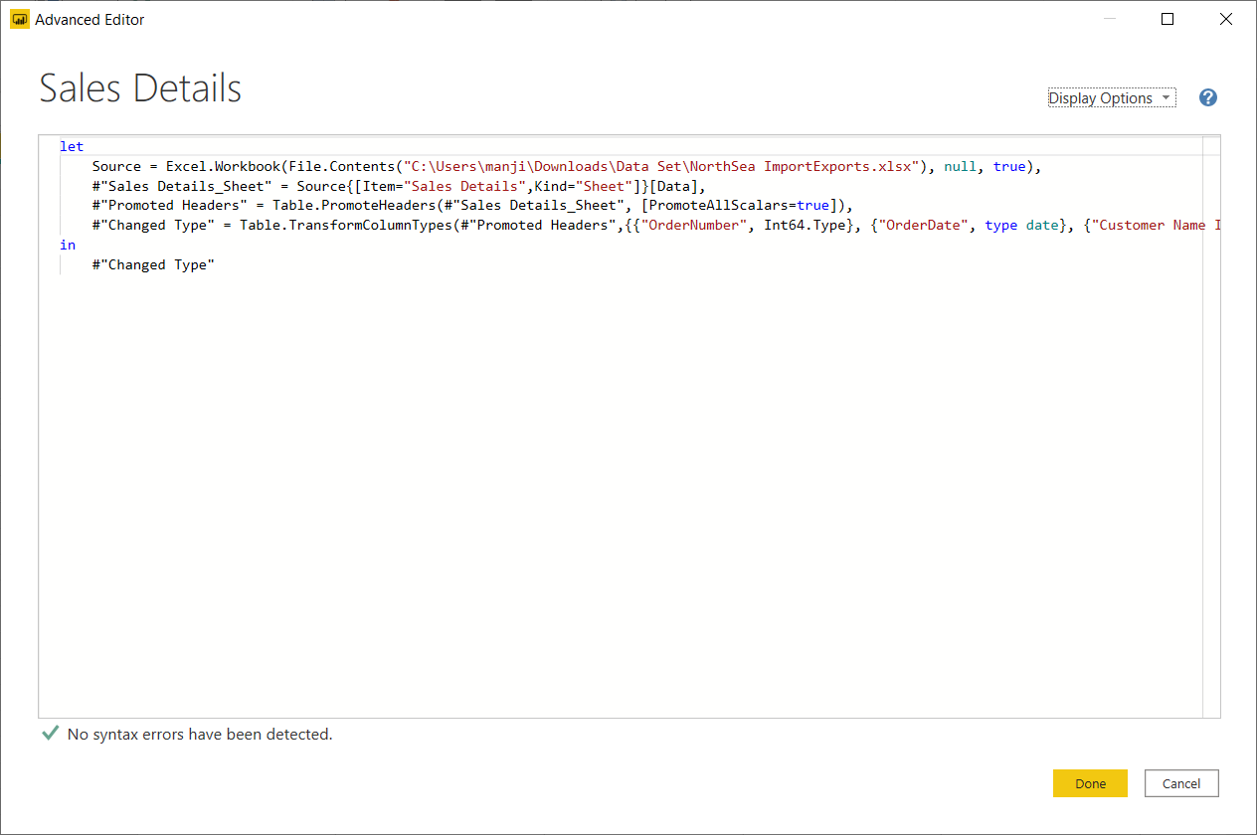

* Prepare a document with details of the following along with their price

− Power BI Desktop

− Power BI Pro

− Power BI Premium

